**Role of Interest-Free Microcredits in Developing Entrepreneurship in Kosovo:**

**Thesis Proposal**

Studying how urban microfinance impacts livelihood transformation in terms of poverty reduction, living standards, social well-being, empowerment and entrepreneurship is the purpose of this study. Microfinance is often seen as a means of reducing poverty. Furthermore, micro-finance institutions are considered as a chance for reconciliation in post-conflict nations like Kosovo. This research investigates the importance of microfinance in Kosovo after the conflict ended, measuring its benefits in terms of general poverty reduction and whether microfinance institutions enhanced access to credit for microenterprises. One of the finest instances of where microfinance may make a difference in reducing poverty and improving access to capital for new microentrepreneurs is in post-conflict nations like Kosovo. With the youngest population in Europe, Kosovo is one of the Balkan republics with the highest percentage of unemployment. The future of microfinance is still unclear for many people, even those who may profit from it since it is not apparent whether it will live up to its promises. For the purposes of this study, the topic of micro-finance is introduced to a larger audience in Kosovo, and the economic effect of micro-finance institutions is evaluated and assessed. Microfinance in Kosovo will also be introduced in this article, which will open up new avenues for further study. As long as financial resources are available, investments are made, and consumer demand and supply balances increase, a country's economy will continue to expand. All citizens, especially those living in developing countries, should be able to take use of the official financial system's goods and services without difficulty. The book contains conceptual and practical ideas from practitioners, best practices from experts, and empirical perspectives from researchers to shape policies, guidelines, strategic planning, and creating projects and activities, as well as to outline directions for future study in this field. Dr. Ananda Suryanarayana is the Director of Postgraduate Studies and Research at this Oman-based university. He is a specialist in the field of management education, having worked in it for 29 years. He is also employed in the mutual fund market for around four years already. At the MCBS, Dr. Dharmendra Singh works as a part-time assistant professor in the economics and finance department. He started teaching finance and accounting to pupils more than 15 years ago.

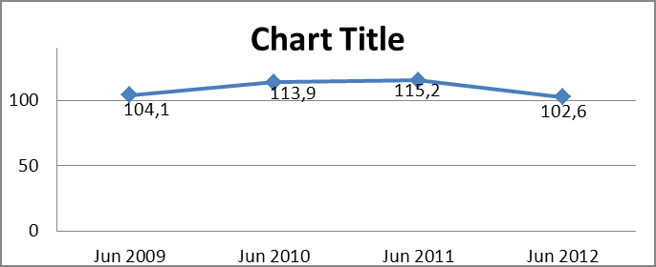

**Keywords of the thesis**

Rural poverty has been a significant problem in Indonesia for decades. To address this issue, rural microfinance institutions play an essential role. Badan Kredit Desa (Village Credit Institution/BKD) is an existing microfinance institution at the village level. This study aims to assess the financial health of BKD and explore whether transformation into a formal form of microfinance institutions can be done to help improve the welfare and economy of people in rural areas. This study used a mixed-method approach to understand the rural microfinance institution's condition by analyzing financial data for the 2016–2018 period and conducting an in-depth interview with BKD stakeholders to explore the possibility of transformation. This study found 15 out of 20 BKDs with relatively healthy criteria that can be transformed into a formal microfinance institution. In comparison, five BKDs that fall under the criteria cannot be transformed into formal ones. Moreover, BKDs have to face internal and external problems that might cause their low financial performance in conducting their operational activities.

**Aim and Objectives**

**Through the provision of modest loans, financial services, and business development services to entrepreneurs, microfinance has an important role to play in encouraging inclusive entrepreneurship. Its key customers are those who are at risk of financial exclusion. Considering that many members of these groups lack personal cash, a history of good credit, collateral, and other forms of assurance, they are seen as excessively hazardous by traditional lenders. Nearly 60 percent of European borrowers are women, making them the most often targeted demographic. More than half of the MFIs (46 percent) focus on rural populations, which is a significant number. Over the last three decades, the microfinance industry has grown at an astounding rate. More than 130 million individuals have benefited from the Grameen Bank model of lending since its inception in 1977 by Nobel Peace Prize recipient Muhammad Yunus. Over 10,000 MFIs have been established across the globe. As a rule, MFIs are based in underdeveloped nations, although a few of them operate in the European Union, particularly in the easternmost members. Global loan portfolio now stands at about USD 145-160 billion (roughly EUR 124-137 billion), and this might rise to almost $400 billion by 2027. Financial and social inclusion as well as job creation and economic growth in general are encouraged by the European Union's microfinance efforts. Among the numerous social policies being implemented throughout Europe, microfinance is becoming more important in promoting self-employment, providing assistance to small businesses, and combating social and financial marginalization. By 2027, the EU market is predicted to reach USD 90 billion (roughly EUR 77 billion), accounting for nearly 23% of the worldwide market. Despite the fact that this growth is behind that of some of the most important markets, such as China, several EU member states, such as Germany, are expecting substantial growth.**

**Subject, Scope and Literature Summary**

Historically, societies had commended on the use of usury interest rates. The ancient societies, mainly based on religious doctrine, consider the sole use of interest for a forbidden activity. According to Ashta ([2010](https://www.tandfonline.com/doi/full/10.1080/23311975.2018.1540072)), in economics of microfinance, ancient Greeks and Romans including Plato and Aristotle inveighed against moneylenders and the very act of charging interest on loans (Vermeersch, [1912](https://www.tandfonline.com/doi/full/10.1080/23311975.2018.1540072)). Dr. Ananda Suryanarayana is currently Director of Postgraduate Studies and Research Department at College of Banking & Financial Studies, Oman. He has 29 years of expertise in the area of management education. He has also served in Mutual Fund Industry for about four years. Dr. Dharmendra Singh is teaching at Modern College of Business and Science (MCBS), Oman. He has more than 19 years of experience in teaching Finance and Accounting courses.

In literature, there are two schools of thoughts to evaluate MFI mission. Researchers have discussed both a welfarist approach to microfinance and an institutionalist approach. One of them is operational self-sufficiency (OSS) and the other is financial self-sufficiency (FSS). OSS normally shows the financial performance of the MFIs, where FSS depicts the actual financial health of MFIs. OSS only incorporates operating income and operating expenses along with a provision of loan loss. But it does not include the cost of capital, which is essential to portray the true picture of the financial sustainability of the MFIs. Thus, FSS includes the cost of capital (adjusted) apart from the factors covered by OSS. Interest rates are a critical factor in gauging the long-term health of a microfinance institution. An MFI's interest rate approach has become a sensitive subject because of this. As a consequence, the most significant influence on interest rate policy is exerted by the social and financial success of an MFI. High interest rates imposed on small loans by MFIs sometimes startle borrowers in underdeveloped countries. Between 2 percent and 4 percent each month, and 20 percent or more annually, depending on the package that the borrower selects are typical MFI interest rates.

Customarily microfinance is viewed as a destitution decrease device, which awards credits to various fragments of poor people (da Silva, 2007). In any case, it ought to be utilized to reduce social issues and give the poor monetary help to assist them with working on their personal satisfaction too (Yunus, Weber, 2007). Various foundations that emphasis on neediness mitigation are subject to benefactor appropriations to deal with the significant expenses of loaning. The expenses are caused on account of the way to deal with give little credits to whatever number borrowers as would be prudent. Consequently, frequently conventional microfinance foundations following the destitution mitigation approach are in many cases subject to contributor monies. Hence, until to date, interests in microfinance were predominantly done as a result of generously thought processes (J.P. Morgan, 2010). In any case, as of late microfinance has been highlighted as a speculation that makes monetary returns too. Accordingly in-accordance with other base-of-the-pyramid business systems (Karnani, 2007) customary financial backers consider microfinance to be a speculation opportunity also. Following this approach some microfinance foundations like the Indian SKS Microfinance or the Mexican Compartamos are now recorded on stock trades to draw in financial backers. Those and comparative organizations follow the monetary frameworks approach (Hermes, Lensink, 2007a; Robinson, 2001). This approach is endeavoring to act however many destitute individuals as could be expected under the circumstances also. Also it underscores the monetary maintainability of microfinance that accompanies business reasonability and institutional development to stay away from giver dependence and to be appealing for financial backers that need to help the development of microfinance.

**Methodology**

Lit=α+β1IFit+β2AVGLSit+β3PRODit+β4Financialperformanceit+β5Sizeit+β6Outreachit+β7AGEit+β8COMPit+β9LendingMethodologyit+β10Regulatedit+β11LegalStatusit+β12DINIit+β13BDIit+β14PDPSMit+β15Regionit+εitModel

This study used three financial performance indicators ROE, ROA, and OSS, which are estimated through three separate models 1(a), 1(b), and 1(c), respectively. Social performance that represents the outreach of MFIs includes both breadth and depth dimensions. The breadth of outreach is shown by the number of CC. However, the depth of outreach is shown by the average loan size (AVGLS).

**Survey and SPSS**

Some of the most common issues faced by small business owners have been studied in surveys conducted around the world. The majority of business owners believe that a lack of capital is the primary impediment to their company's ability to grow. Given the region's underdeveloped capital market, this is particularly noteworthy. Providing microloans to SMEs, particularly in developing countries like Kosovo, is a critical strategy for fostering the growth of existing businesses and enhancing their performance. Purpose: Microfinance institutions could have a significant impact on the growth of SPSS in Kosovo, according to this article. According to the method, a descriptive approach is used to compare a wide range of publications on the subject. Microfinance has several advantages for small businesses in Kosovo, and the promotion of microfinance and the availability of microcredit or small loans to SMEs in Kosovo has proven to be a successful solution to working capital breakdown concerns

**Purpose:** The purpose of this paper is to review the presumable impact and crucial role of microfinance institutions on the development of SPSS in Kosovo. Methodology: The methodology is based upon a descriptive approach whereby a comparison is made between different reports, papers, journals and other literature on the subject.

**Findings:** According to the available statistical and financial data, the benefits of microfinance are multiple and the promotion of microfinance and the availability of micro credit or small loans to SMEs in Kosovo has been shown to succeed as a solution to meltdown problems with working capital.

**Expected impact**

The proponents of inclusive financial development think that the MFIs' reaction to the demand of their present and future customers is to provide proportionally bigger loans to the non-poor or near-poor businesses. Although opposition is more likely to evaluate responses such as the MFIs' mission drift. The purpose of this research, therefore, is to examine the impact of micro enterprise loans on entrepreneurs' income and creativity. Our results provide credence to those who argue in favor of providing loans to business owners. Larger loans enhance revenue, but less inventive company practices might jeopardize that income. Therefore, we propose that MFIs give micro enterprise loans accompanied with appropriate business skills, knowledge, and technology to guarantee that the loan capital is effectively used.

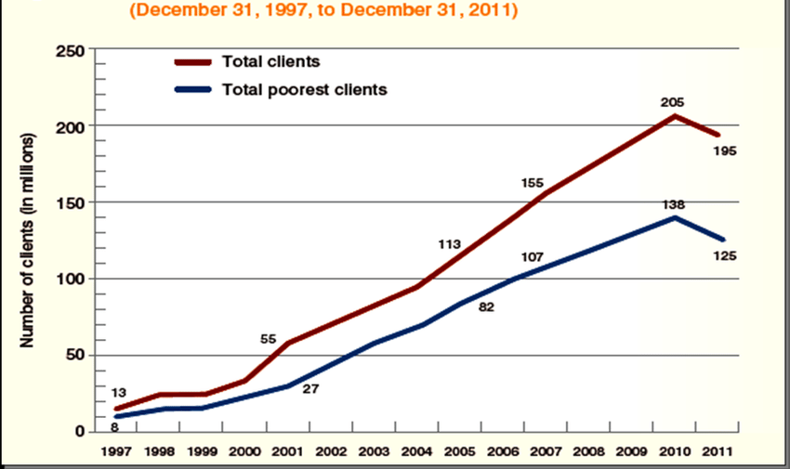

**Expected impact table:-**

**1. Journal, Conference, Book**

|  |  |  |  |
| --- | --- | --- | --- |
| Indicator | Df | T | Sig. |
| Yield on grass loan portfolio | 39 | -0.79 | 0.43 |
| Costs per borrower | 41 | -0.82 | 0.42 |
| Operational self sufficiency | 30 | -0.48 | 0.64 |
| Profit margin | 42 | -0.94 | 0.35 |
| Percentage of female borrowers | 30 | -0.20 | 0.84 |

1. **Expected impact from Thesis:**

Regarding the benefit status there were no huge contrasts between for benefit and non-for benefit microfinance organizations neither for the productivity estimates yield on the net credit portfolio, costs per borrower, functional independence, overall revenue nor for the level of female borrowers. The equivalent is substantial for contrasts between microfinance establishments with various missions as introduced in table. Again no huge contrasts could be found for productivity estimates yield on the net credit portfolio, costs per borrower, functional independence, overall revenue, and level of female borrowers separately. Microfinance increments family pay, which prompts food security, the structure of resources, and an improved probability of teaching kids. Microfinance is likewise a method for self-strengthening. It empowers the poor to make changes when they increment pay, become entrepreneurs and diminish their weakness. Concerning neediness lightening, microfinance makes business and creates pay, subsequently invigorating social prosperity among the unfortunate portions of society and filling in as a significant apparatus for destitution decrease in both creating and created economies.